Patrick Walsh and Patrick Mitchell:

R Script:
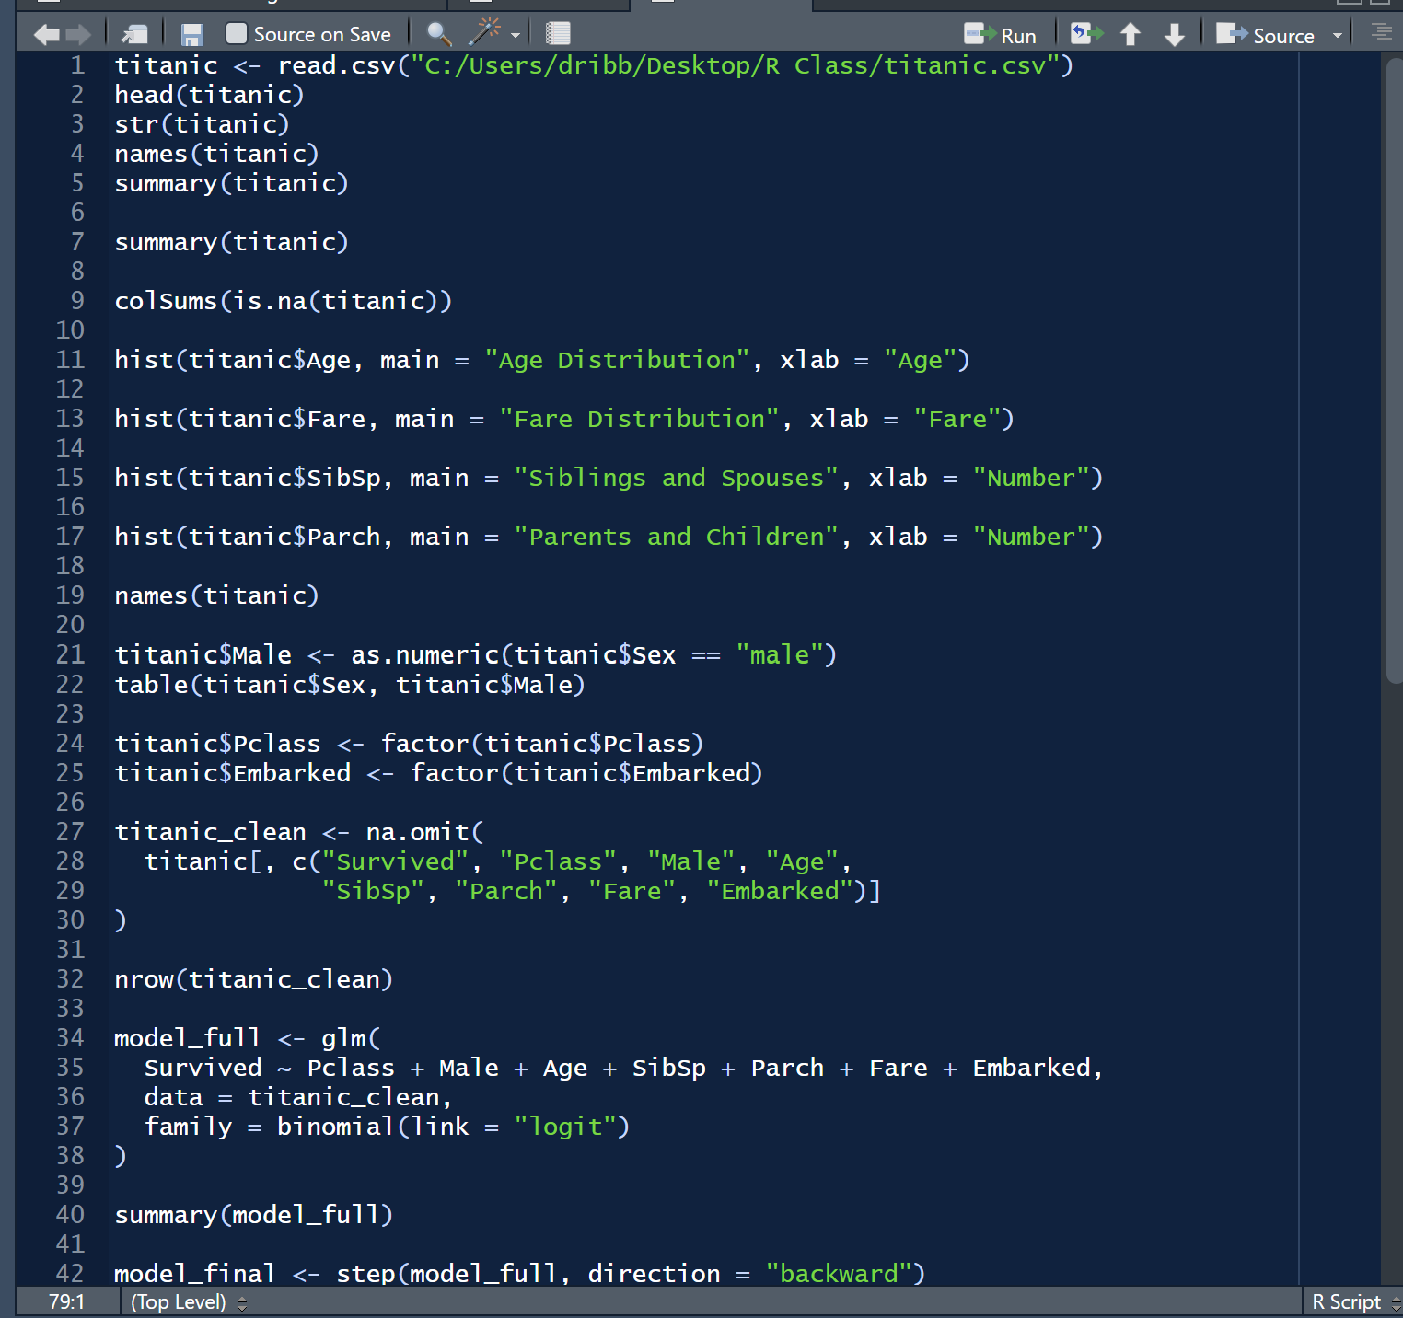
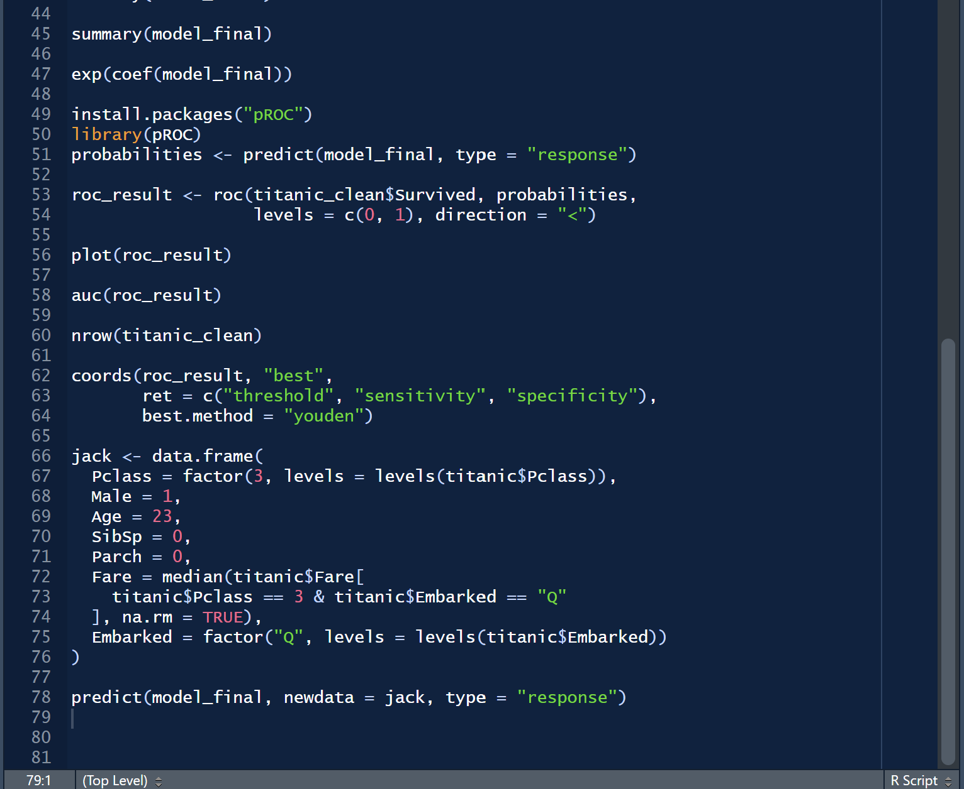

R Console:
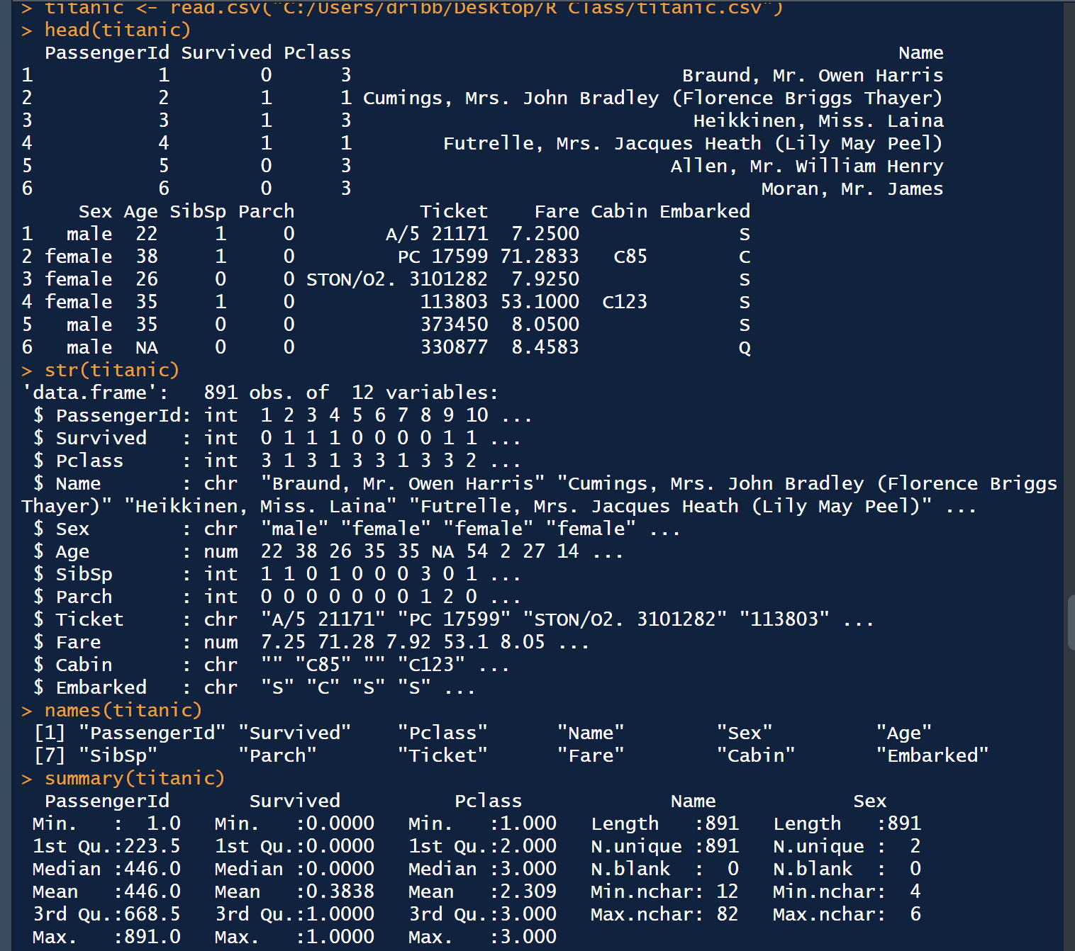

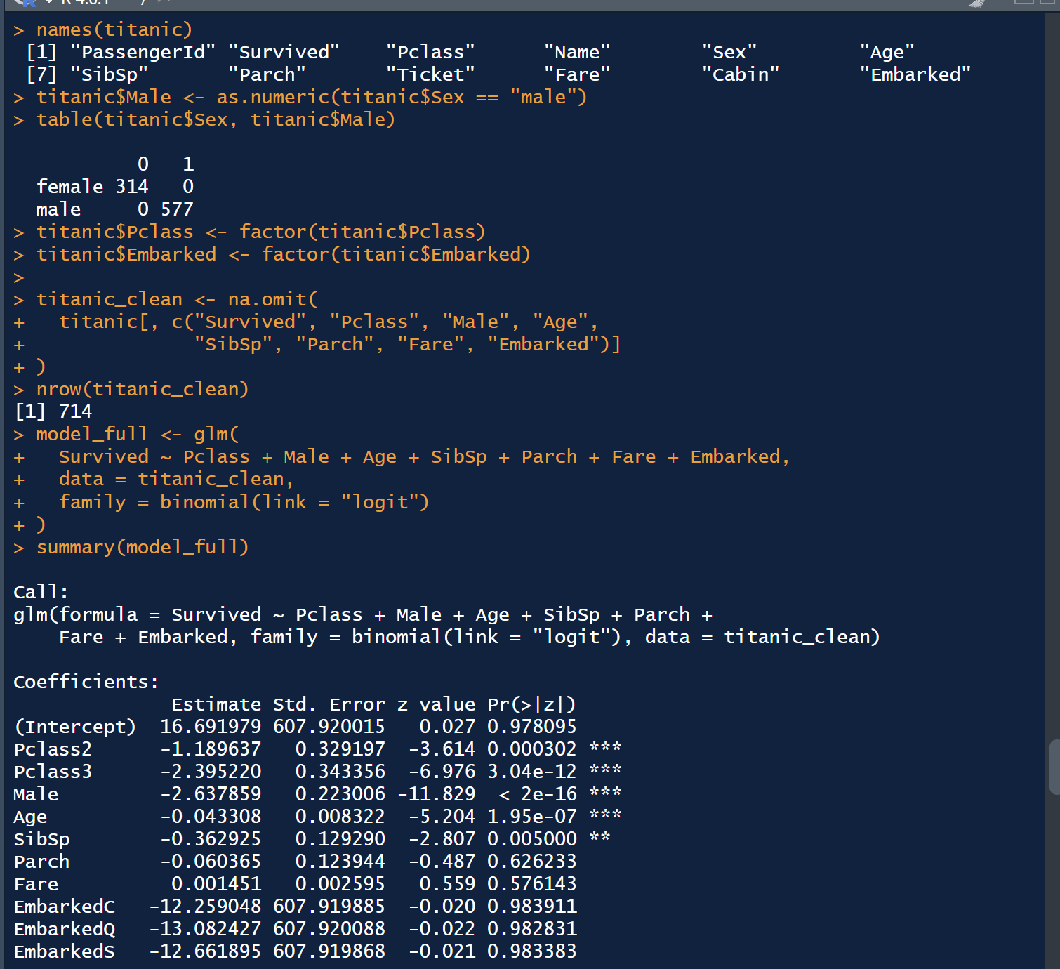
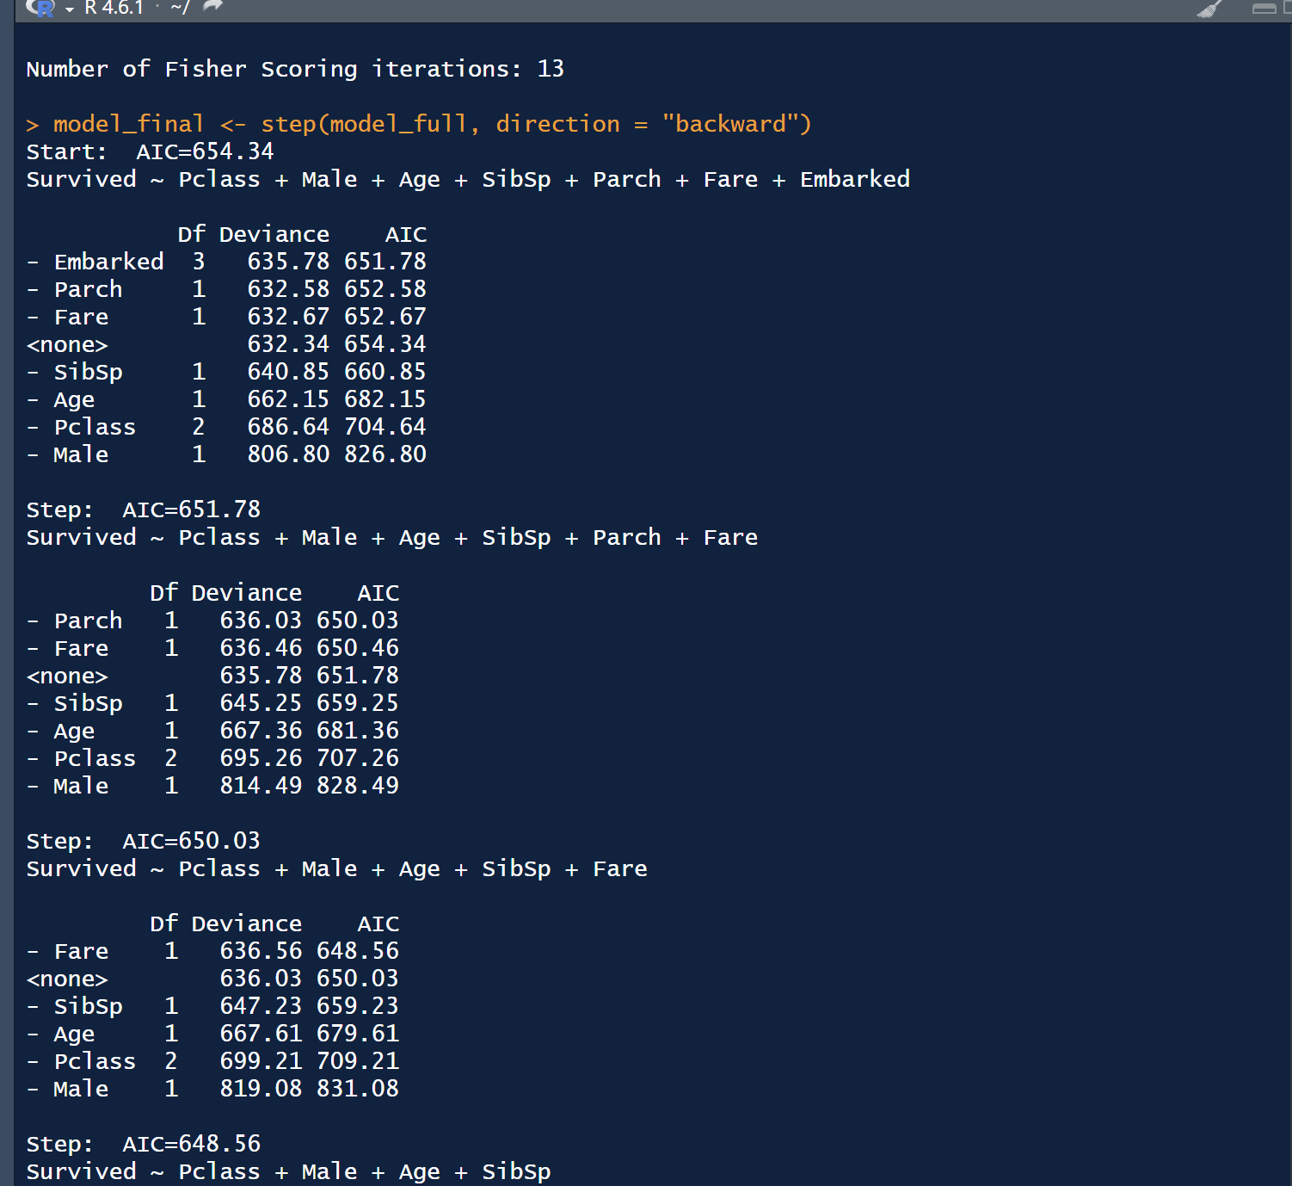

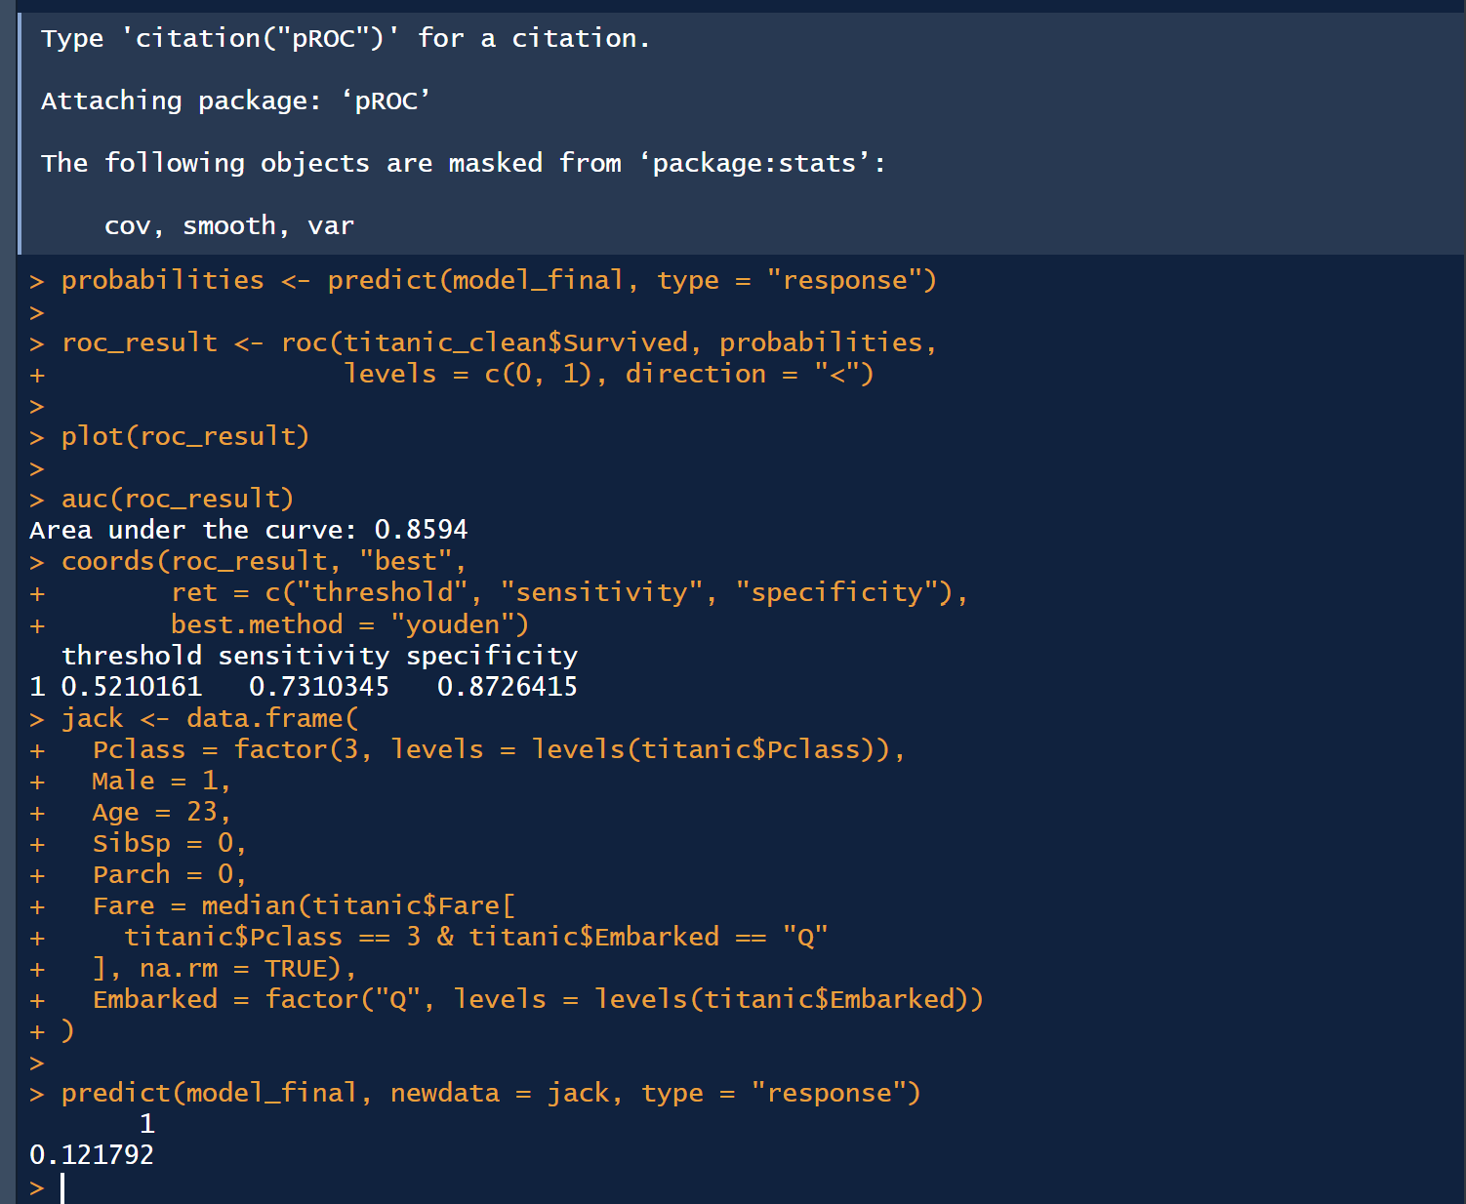

Histogram of Age Distribution:
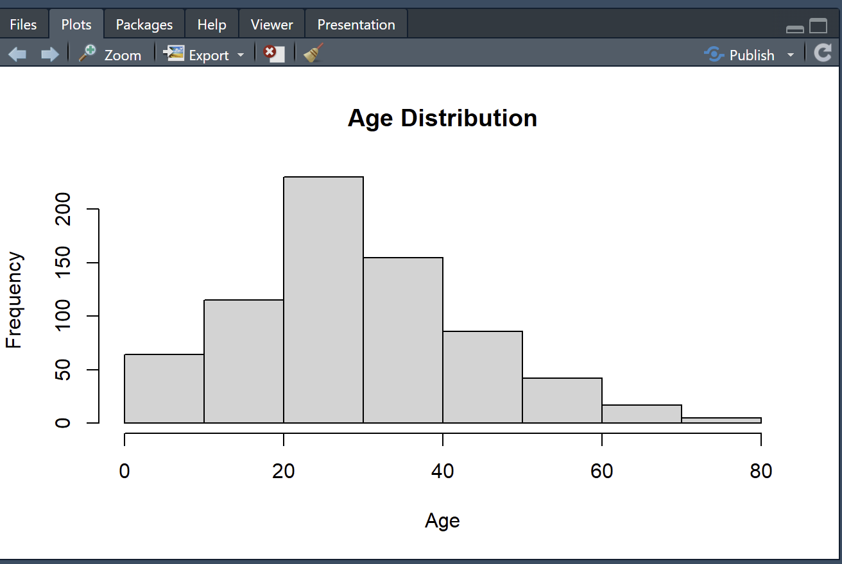

Histogram of Age Distribution:
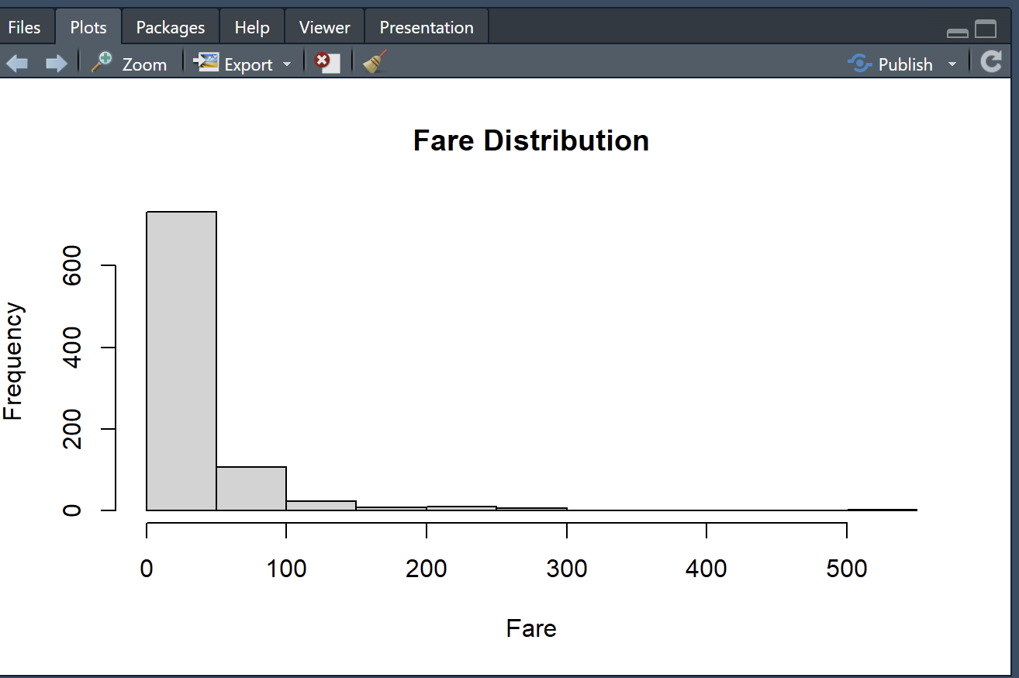

Histogram of Siblings and Spouses:
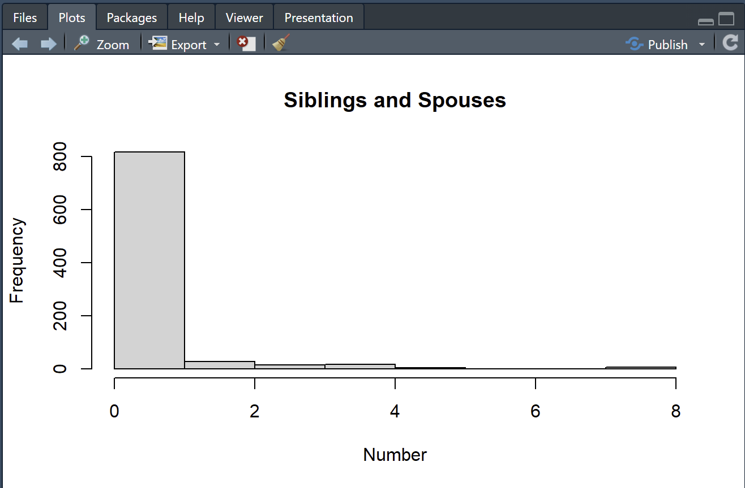

Histogram of Parents and Children:
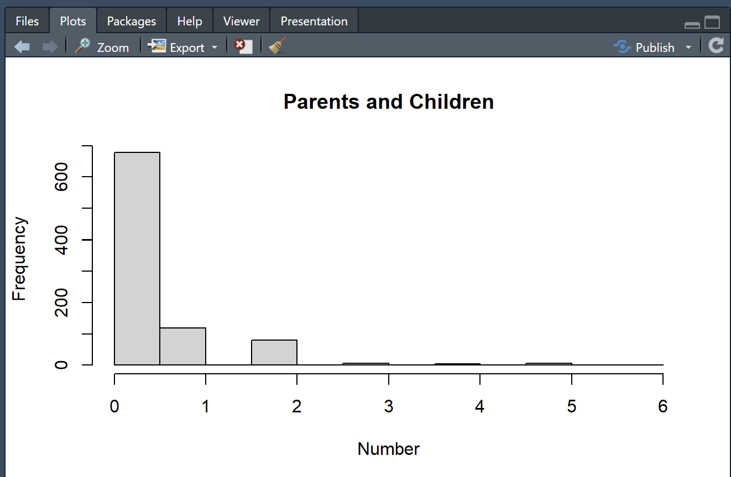
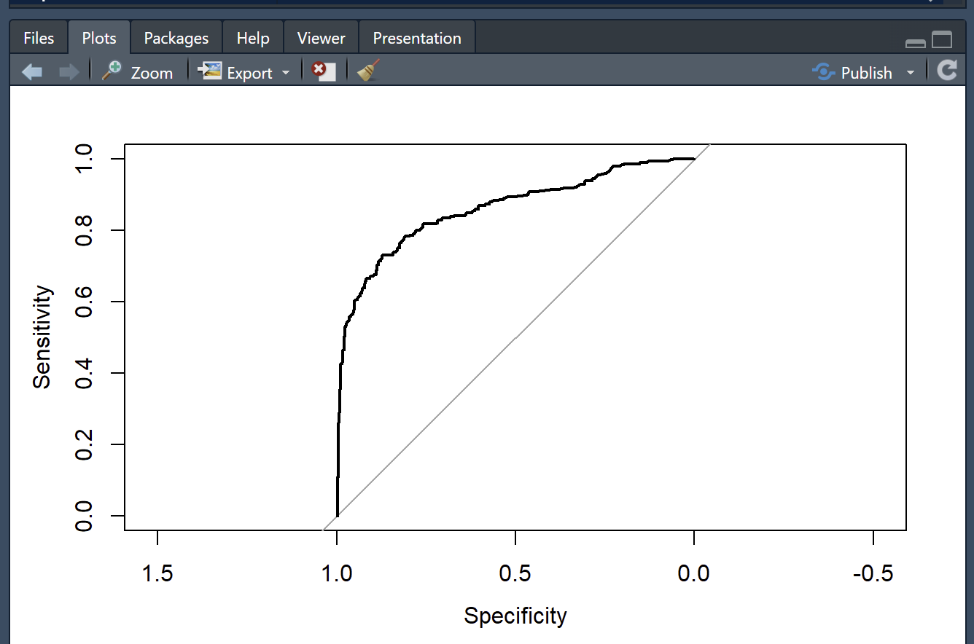

1. Interpret the coefficients
The final logistic regression model included passenger class, gender, age, and number of siblings/spouses aboard.
- Passenger Class: Second-class passengers had approximately 75.5% lower odds of survival than first-class passengers, while third-class passengers had 92.9% lower odds.
- Gender: Female passengers had approximately 13.7 times higher odds of survival compared to males.
- Age: Each additional year of age decreased the odds of survival by approximately 4.4%.
- SibSp: Each additional sibling or spouse aboard decreased the odds of survival by approximately 31.5%.
Overall, gender and passenger class were important predictors of survival. These effects are interpreted while holding the other variables constant.

2. Run a confusion matrix
Using a probability cutoff of 0.50, the final logistic regression model produced the following confusion matrix:
Actual / Predicted | Did Not Survive | Survived
Did Not Survive | 364 | 60
Survived | 78 | 210
- Accuracy: 80.62%
- Sensitivity: 72.92%
- Specificity: 85.85%
The model correctly predicted 574 out of 712 passengers. Overall, the model performed well on the training data, with higher accuracy in identifying passengers who did not survive compared to those who survived.

3. Jack O'Malley's likelihood of survival
Jack O'Malley is a 23-year-old male traveling in third class with no family aboard. He boarded the Titanic in Queenstown, Ireland.
Using the final logistic regression model, his predicted probability of survival is 12.18%.
Since his survival probability is below the 50% cutoff, the model predicts that he will not survive. His gender and third-class status contribute to his low probability of survival. His boarding location does not affect the prediction because it was removed during step-down regression.

